Project Proposal
Academic Year 2010/2011

Candidate Details

Index No: R051257

Name of candidate:
M Sandun Dhammika Perera
......................................................................................................................................

Address:
No 29,
Dias Place,
Panadura.

Contact telephone numbers:
+94774720192
......................................................................................................................................

Email:
sandundhammikaperera@yahoo.com
sandundhammikaperera@gmail.com

Supervisor Details

 | Supervisor 1 (IT Related) | Supervisor 2 (Optional)
Name | Mr. Viraj Pinto Jayawardena.
Designation | Chairman/Managing Director.
Workplace address | Matrix Institute of Information Technology(pvt.) Ltd.  279/3,Galle Road,Colombo 4.
Academic/  professional/  qualifications  and  memberships | B.Sc Hons(computing & IS) –UK MIEEE,MBCS CITP.
Work experience | 15 years of IT training and education.
Email: | viraj@matrix-edu.com
Phone number/s | +94714317927

Note: Any deviation of the final project from the project described in this proposal should
be explained by the candidate in the dissertation.

Project Details

Title of Project:

R051257 Offlie Test engine for Matrix Institute of Information Technology.

Repeat Student
Number of Attempt: …………………………………………………………………………

Earlier Project Title:
……………………………………………………………………………………………………..

……………………………………………………………………………………………………...

Name and address of client:
279/3, Galle road , Colombo-04
......................................................................................................................................

......................................................................................................................................

......................................................................................................................................

......................................................................................................................................

......................................................................................................................................

Motivation for project:
- To complete the final year project and have a idea about necessary software
Engineering skills by involving with a real world project.

2. Automate the process of student assignment process. Assignments can be
Completed using a computer and also validate and verity their level of skills or academic
Progress with a fully automated computerized paridgm.

- Provide students a highly portable and performance lightweight standalone
Application to do their tests or assignments.

3. Provide teachers a highly user friendly and simple interface to make their own
Assignments and publish them as files on the internet or local file host.

4. Provide extensibility to the software.

......................................................................................................................................

......................................................................................................................................

......................................................................................................................................

......................................................................................................................................

......................................................................................................................................

......................................................................................................................................

......................................................................................................................................

......................................................................................................................................

......................................................................................................................................

Objectives and scope of proposed project:
1. Targeting only the win32 platform. Sacrifice the platform independence to the performance

- Supports MCQ type questions only.

3. Targeting a one client only. All the copyrights of the software is reserved my
Original client.

Critical functionalities for project:

- Indignity of the data structures and file structure and file formats.

2. Validation of the input text/binary data limits.

3. Easy to learn user interfaces.

- Compatible for windows 2000 and above operating system environments.

- Also should support under the Reactos Operating system.

- Support Extensibility.

Itemized list of deliverables of the system:

Note: Deliverables are items that you would deliver to the client at the end of the project.

- Question Maker software

- Test Taker software.

- Documentation.

- Bugzilla.

- Project wiki page.

Work breakdown structure for project (include the work involved in system development as well as writing the dissertation):
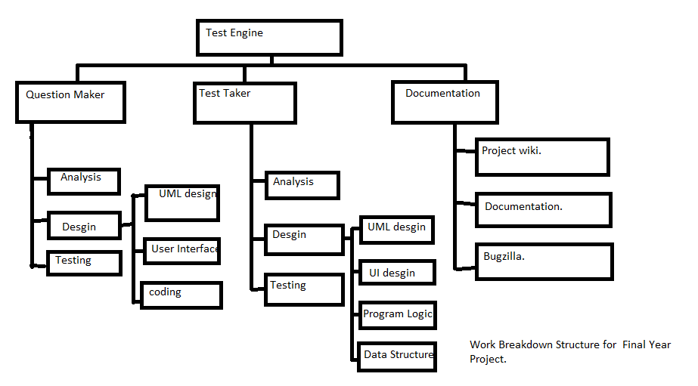
Resource requirements for project (e.g., hardware,software,...):

Hardware: A x86 computer with a processor i686 or above.
LCD/CRT display with the resolution 1360x768. May also work on other
Resolutions but originally designed for the above mentioned dimension.
Standard PC mouse and keyboard.

Software: windows 2000 or above or Reactos operating system(s).
Web browser (IE/Safari/mozilla or chrome).

Proposed way of evaluating the success of your system:

Alpha Testing: Validating the application using bellow mentioned test cases.
- Validating the file formats and data structures against correctness.
- Validate user interfaces collecting different people’s ideas about how they feel about the user interfaces.
- Validate other features.
- Complexity of the software.
- Functionalities of the software.
- Applicability.

Beta Testing: Deploy the application in the institute and test using the real users who involving with the system and also maintain the simplicity of the documentations and find out how to decrease the length of the learning curve.

